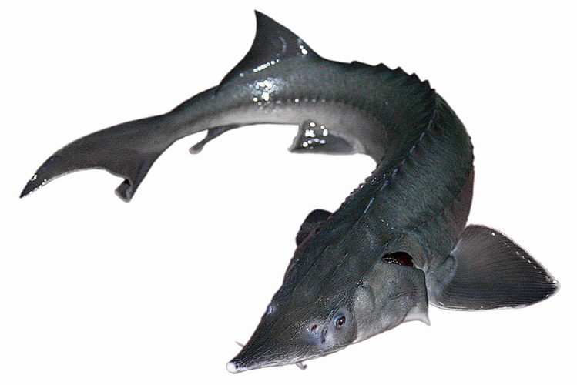

Our Pride!!!
Today sturgeon is grown in farms, because wild sturgeon is a threatened species. Sturgeon is one of the world’s oldest fish, it was found on Earth up to 250 million years ago.
Sturgeon meat is considered a high quality product both for children and pregnant women.
In the industry, the fish is extremely valuable; the meat of the fish is of high quality and tasty. However the high value of the fish has also been the reason for its decreasing wild population.
A historically world famous region for its storage is the Caspian Sea coast, which was mostly inhabited by Slavs, and those of Muslim and Jewish faith. Those of Muslim and Jewish faith were not allowed to get nourishment from sturgeon, because fish with no scales were considered an unholy form of nourishment. The Slavs, however, had no objections to eating sturgeon. For example, as we can read in the literature, the Cossacks, serving as the Tsar’s border guards, were granted exclusive rights to fish for sturgeon in the River Ural during migration of the fish. They even took care to not decrease sturgeon stocks and started fishing exclusively after the ataman had opened the season in the middle of September. Different sturgeon species were caught in Russia, Germany, France and elsewhere. During the Middle Ages the kings of England, Denmark and Spain promulgated a rule that all caught sturgeon was crown property. The fish was also highly valued by Mongol conquerors, who requested a share of dues in sturgeon from the dependent territories.
In the course of history sturgeon products have achieved high recognition and demand in traditional cuisines of many folks and it is named an exclusive delicacy due to its taste qualities.
Enjoy Grantiņi-g<rown sturgeon in different dishes.

